EL.a-x - Elements of life | EL1-9

EL.Q Exam questions from past papers
Explain why each element has a characteristic emission spectrum (4)? | As each element has electrons in discrete energy levels (1) to which electrons drop levels (1) with different elements having different sized gaps (1) due to the energy released being proportional to frequency E=hv (1) and so the energy drops between levels give lines
Why do isotopes have the same chemical properties (1) ? | This is because they have the same number of electrons in their outer shells (1)
What does an emission/line spectrum show? (3) | It shows the frequency of light given out when an electron moves down energy levels in the form of coloured bands on a black background with the lines getting closer together (converging) with increasing frequency (3)
What does an absorption spectrum show? (3) | It shows the frequency of light absorbed by electrons in the form of dark bands on a colour spectrum with the lines getting closer together (converging) with increasing frequency (3)
Geiger and Marsden found that the majority of alpha particles were hardly deflected. A very few were deflected a great deal 'like firing an artillery shell at a cigarette paper and having it 'bounce back'.  How does their model of the atom explain that some, but only a few, alpha particles 'bounce back'? (3) | Alpha particles are positive and so they are deflected by the positive nucleus (1) the ones that hit the nucleus bounce back (1) but not many of them do this as the nucleus is small (1)
A student says that the cloudiness is caused by insoluble calcium hydroxide being formed slowly. Comment on this statement (2) | Calcium hydroxide is partially soluble (1) so dissolves at first then appears (1)
In 1911, Geiger and Marsden fired α-particles at gold foil and found that most passed through unchanged, while just a few were deflected by large amounts. This was evidence for the nuclear model of the atom.  Explain the results of the Geiger and Marsden experiments using a nuclear model of the atom. (3) | Most of the atom is empty space so particles can pass undeflected (1) There are positive protons in the nucleus (1) that deflect alpha particles a lot (1)
What is the avogadro’s constant the number of for a ionic (NaCl),covalent (CO₂ ) and metallic (Cu) structure?  And therefore the answer to this question  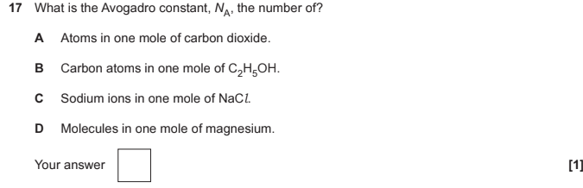 | - The number of sodium or chloride ions in one mole of NaCl (6.02x10²³ ions)  - The number of CO₂ molecules in one mole of CO₂ (6.02x10²³ molecules)  - The number of copper atoms in one mole of Cu (6.02x10²³ atoms)  - C
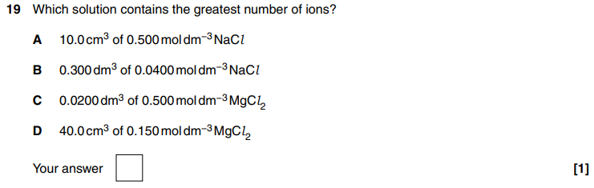  Which solution contains the greatest number of ions? | C  - A is 0.01x0.5 = 3x10²¹ x 2 = 9x10²¹  - B is 0.3x0.04 = 7.2x10²¹ x 2 = 14x10²¹  - C is 0.02x0.5 = 6x10²¹ x 3 = 18x10²¹  - D is 0.04x0.15= 3.6x10²¹ x 3 = 10x10²¹  - Therefore its C

EL.a-d - Formulae, equations and amount of substance | EL1 | EL6 | EL7 | EL9 |
What is another name for fizzing? | Effervescence
Define empirical formula? | The simplest ratio of atoms of each element in an element/compound
Define molecular formula? | The actual number of atoms of each element in an element/compound
Define isotope? | Atoms with the same number of protons but a different number of neutrons
Define relative atomic mass? | The average of the masses of all isotopes taking into account their abundance relative to 1/12 of the mass of carbon-12
Define relative isotopic mass? | The mass of an atom of an isotope relative to 1/12 of the mass of carbon-12
Define Relative molecular/Formula mass? | The mean mass of a molecule relative to 1/12 of the mass of carbon-12
Why do isotopes have the same chemical properties? | They have the same number of electrons in their outer shells
What is the relative mass of an electron? | 1/1840
How do isotopes of the same element vary? | In physical properties (e.g., density)
Define both cation and anion? | - Cation - positively charged ion  - Anion - negatively charged ion  Remember as cats make you positive
What is the equation to convert g/dm³ to mol/dm³ | g/dm³ / RFM = mol/dm³
How would you convert from mol/dm³ to g/dm³ | mol/dm³ x RFM = g/dm³
What is a hydrated/hydrous salt? | A salt molecule loosely attached to water ( called waters of crystallisation)  Thus anhydrous means the opposite
What is the equation using Avogadro's number? | Number of particles (N) = Avogradro’s number (N_{A}) x number of moles (n)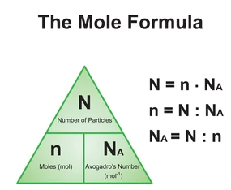

EL.e-h - Atomic structure | EL1 | EL3 | EL4
What is Nuclear fusion? | The joining of 2 or more smaller lighter nuclei to make a heavier nucleus (under conditions of high temperature and pressure)
What is the electron configuration of chromium? | 1s² 2s² 2p⁶ 3s² 3p⁶ 4s¹ 3d⁵ or [Ar] 4s¹ 3d⁵
What is the electron configuration of copper? | 1s² 2s² 2p⁶ 3s² 2p⁶ 4s¹ 3d¹⁰ or [Ar] 4s¹ 3d¹⁰
Which shells have which subshells? | - 1 has s  - 2 has s p  - 3 has s p d  - 4 has s p d f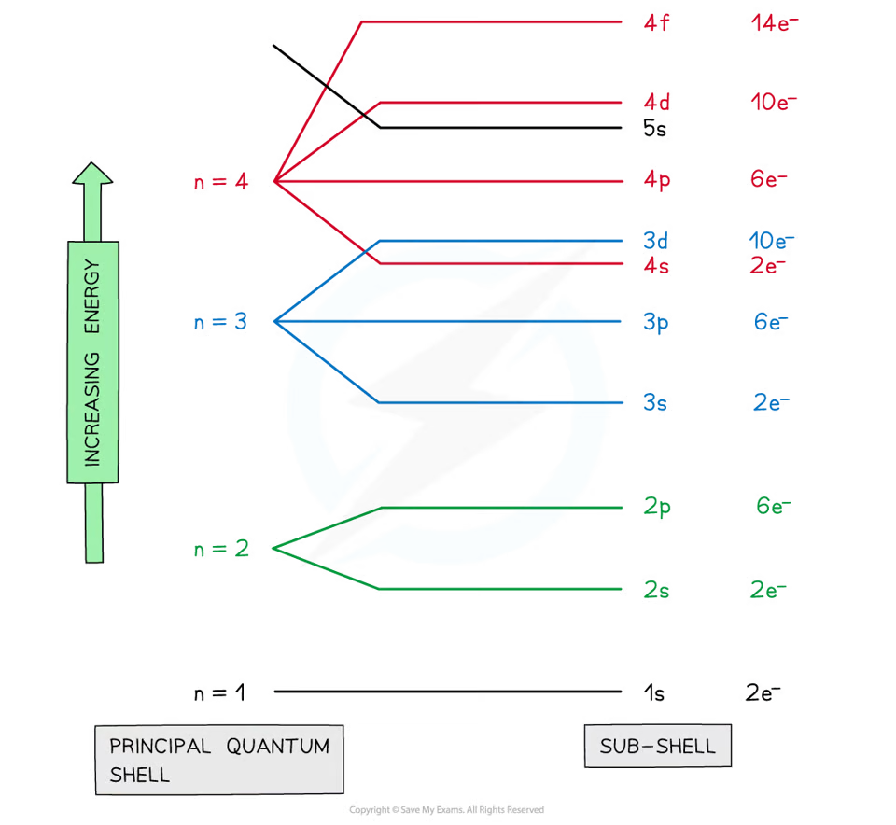
Define orbitals? | Regions around the nucleus that can hold 2 electrons with opposite spins  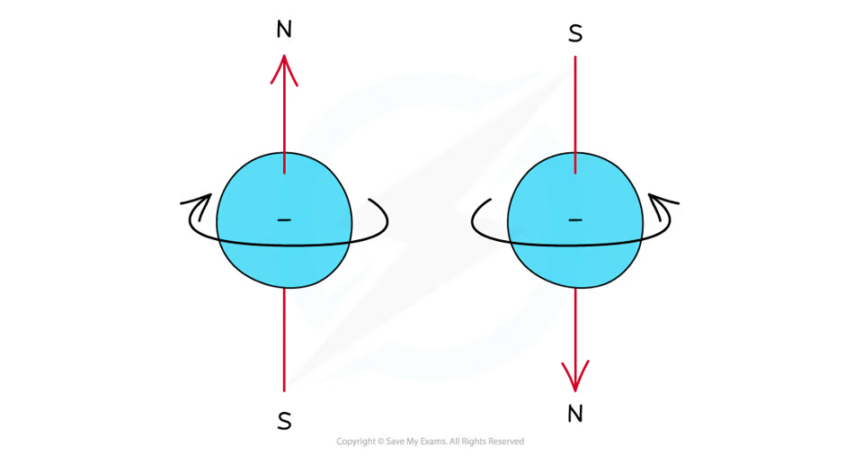
How many orbitals does each subshell have? | - S has 1 orbital  - P has 3 orbitals  - D has 5 orbitals  - F has 7 orbitals
What is the shape of an s-orbital/s-subshell? | Sphere  The greater the shell number, the greater the radius
What are the shapes of the p-orbitals? | Dumbbells.  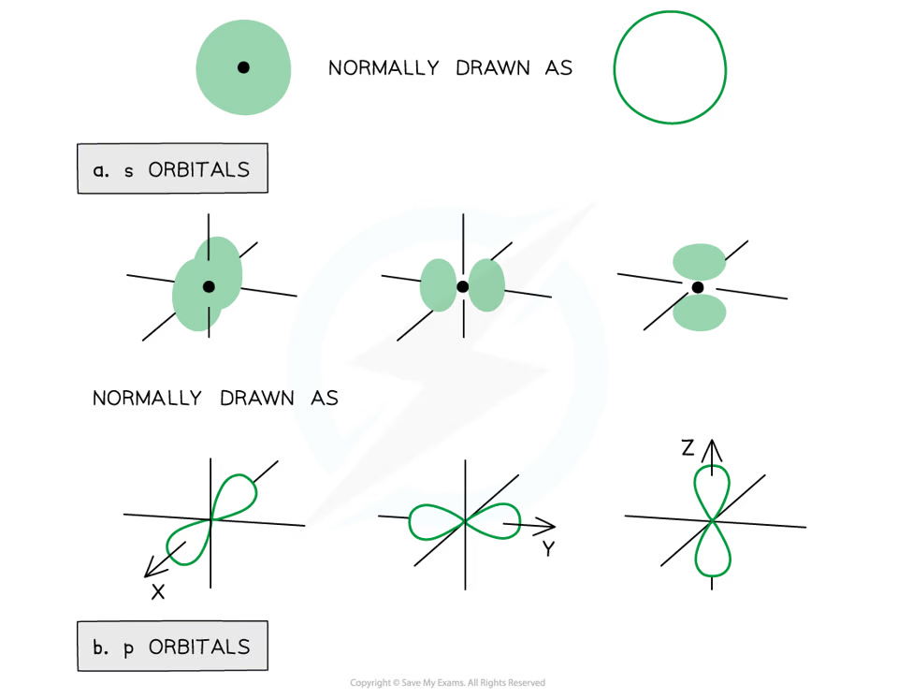
What are the 2 rules for all orbitals of the same energy? | - Electrons won’t pair in the same subshell if they don’t have to  - Electrons in the same orbitals must have opposite spin  - This is to avoid repulsion
What are the blocks of the periodic table? | 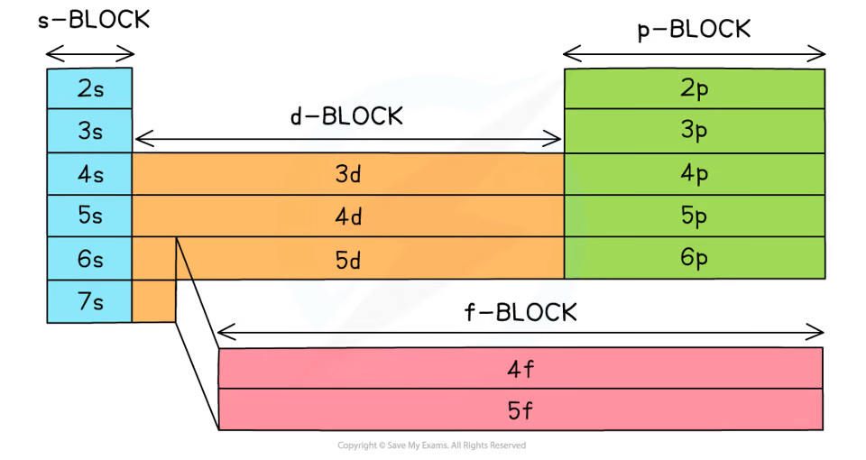
What are outer shell electrons also known as? | Valence electrons
What is the nuclear formula for a Proton? (Draw or in the form Ar/An E) | 1/1 p  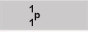
What is the nuclear formula for a Neutron? (Draw or in the form Ar/An E) | 1/0 n
What is the nuclear formula for a Electron? (Draw or in the form Ar/An E) | 0/-1 e
How was Mendeleev's adaptation of the periodic table different and why was this?  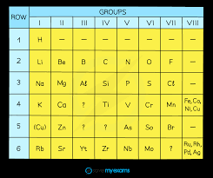 | - He left gaps and he ordered elements horizontally in terms of atomic weight  - He also realised that elements with the same properties should be placed in the same column and so the gaps he left relates to undiscovered elements and some elements didn’t fit in as isotopes had not been discovered
What was the order in which the model of the atom was developed and by who? | - Dalton model - John dalton (1803)  - Plum pudding - J.J thomson (1897)  - Nucleus - Geiger & mardsen (Rutherford as well) [1909-1911]  - Shells - Niels bohr (1913)
Geiger and Marsden found that the majority of alpha particles were hardly deflected. A very few were deflected a great deal 'like firing an artillery shell at a cigarette paper and having it 'bounce back'. How does their model of the atom explain that some, but only a few, alpha particles 'bounce back'? (3) | Alpha particles are positive so they are deflected by the positive nucleus (1) The ones that hit the nucleus bounce back (1) But not many do this as the nucleus is small (1)
Give 2 reasons for the percentage yield being less than 100% | - Reaction may have not had enough time to go to completion  - A side reaction has taken place  - Product was lost under purification  - Reversible reaction
What is a covalent bond? | A shared pair of electrons
Draw the dot cross diagram of CaBr₂? | 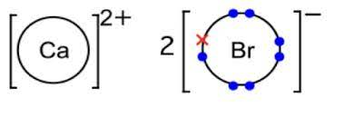
Which transition metals have anomalous e⁻ structures and why? | - Copper ([Ar] 3d¹⁰ 4s¹) and chromium ([Ar] 3d⁵ 4s¹)  - Having a half built/full built 3d subshells is lower in energy than a full built 4s subshell

EL.i-l - Bonding and structure | EL5 | EL7 |

What are the 4 types of bonding and structure? | Giant Covalent, Giant metallic, Giant ionic,Molecular covalent,
Define ionic bonds. | The electrostatic force of attraction between oppositely charged ions formed by electron transfer
Describe and explain the conductivity of Giant ionic compounds under different states | - Doesn’t conduct when solid (1) because the ions are fixed in a lattice (1) so cannot carry a charge  - Conducts when molten or dissolved because the ions can move and thus act as charge carriers
What are the properties of Giant Ionic structures (Mp/Bp, hardness, type of Bond, El Cond, Sol in H₂O, Sol in NPS) | - MP/BP is high  - Hard but brittle  - Strong ionic bonds between oppositely charged ions  - Conducts when molten or in solution  - Solubility is soluble in polar solvent (eg water as it forms ion-dipoles this is in Oceans topic)  - Solubility is insoluble in non polar solvents
What are the properties of Simple Molecular Covalent structures (Mp/Bp, hardness, type of Bond, El Cond, Sol in H₂O, Sol in NPS) | - MP/BP is low  - Soft  - Weak intermolecular bonds between molecules and strong covalent bonds between the atoms within the molecules  - Does not conduct  - Usually insoluble in water  - Usually soluble in polar
What are the properties of Giant Covalent structures (3 Examples, Mp/Bp, hardness, type of Bond, El Cond, Solubility) | - Diamond graphite silica (silicon dioxide)  - MP/BP is Very high  - Very hard if 3D  - Strong covalent bonds  - Does not conduct except for graphite  - Solubility no never
What are the properties of Giant Metallic structures (type of particle, Mp/Bp, type of bond ,hardness, El Cond, Sol in H₂O and NPS) | - Ions in a sea of delocalised electrons  - MP/BP is High  - Strong electrostatic attractions between positive ions and delocalised electrons  - Hard but malleable  - Conducts when solid or liquid  - Insoluble in water and non polar solvents
What are the properties of Macromolecular Covalent (type of structure, type of particle, 2 examples, Mp/Bp, hardness, type of Bond, El Cond, Sol in H₂O, Sol in NPS) | - Polymers  - Long-chain molecules  - DNA, protein  - MP/BP is moderate often decomposes on heating  - Does not conduct normally  - Usually insoluble in water  - Sometimes soluble in non polar solvents
What are the steps for writing ionic equations? Remember BBC | - Balance the equation.  - Break each (aq) substance into ions  - Cancel any ions on both sides (these being the spectator ions)  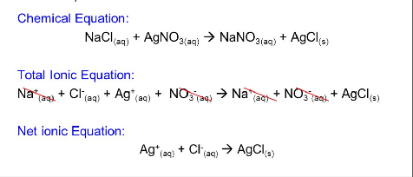
What are spectator ions? | Ions that aren’t changing state or oxidation number
Define one mole? | The amount of substance which contains the same amount of particles as there are atoms in 12 grams of carbon-12
What is a dative (coordinate) bond? | A shared pair of electrons where both electrons are from the same atom
What is used to show a dative bond? | An arrow from the atom providing the dative bond E.g. in an ammonium ion  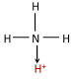
Give the 3 bond angles largest to smallest. | - The bond angle between lone pairs  - The bond angle between a lone pair and a bonding pair  - The bond angle between bonding pairs
What do lone pairs repel by and why? | An extra 2.5 degrees as they’re closer to the nucleus and thus take up more space
Describe the linear shape of a molecule with an example? | - 2 bonding pairs  - 180 degrees  - An example is CO₂  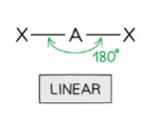
Describe the triangular planar shape of a molecule with an example? | - Planar meaning flat on the page and all the bonds are in the same plane  - 3 bonding pairs and 0 lone pairs  - 120 degrees
Describe the tetrahedral shape of a molecule with an example? | - 4 bonding pairs  - 109.5 degrees  - An example is CH₄  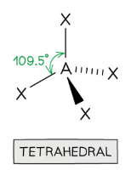
Describe the (Trigonal) pyramidal shape of a molecule? | - 3 bonding pairs and 1 lone pair  - 107 degrees (because tetrahedral minus 2.5 degrees)  - An example is NH₃  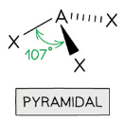
Describe the V shape or Bent shape of a molecule? | - 2 bonding pairs and 2 lone pairs  - 104.5 degrees between bonding pairs (because tetrahedral minus 2 x 2.5 degrees).  - An example is H₂O  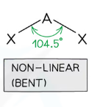  The angle between the two lone pairs is the greatest
Describe the Bi pyramidal shape of a molecule? | - 5 bonding pairs  - 120 degrees and 90 degrees  - An example is PCl₅  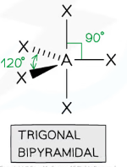
Describe the octahedral shape of a molecule with an example? | - 6 bonding pairs  - 90 degrees  - An example is SF₆  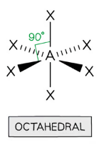
How should you tackle a “Explain the shape of molecule” question in 4 steps? | - State the total no. of pair of electrons and ALSO containing this no. of bonding and lone pairs ‘surrounding the central atom’  - State that ‘electron sets arrange themselves as far apart from each other to minimise repulsion`’ (1)  - If there are lone pairs, state lone pairs repel more than bonding pairs (1) Otherwise state electron pairs get repelled equally (1)  - State the shape of a molecule with the bond angle  Treat double bonds as single bonds here and the total no. is both lone and bonding pairs, if they give you or you could identify the central atom say the atom of the central atom, not just ‘ central atom’
What is the sentence Mrs Marsden wants you to know for Electron sets :) ? | Electron sets arrange themselves as far away from each other to minimise repulsion
How does the structure of elements change across period 3? | - Na, Mg, Al - giant metallic lattices  - S - giant covalent lattice  - P₄, S₈, Cl₂, Ar- simple molecular
How does the structure of elements change across period 2? | - Li, Be, B - giant metallic lattices  - C - giant covalent lattice  - N₂, O₂, F₂, Ne - simple molecular
What is the mnemonic for remembering the shapes of the shape of molecules from 2 bonding pair to 6 no lone pairs shapes included | Large Turtles Play Tennis Plus Beat To Break Oranges  Linear, Trigonal Planar, Tetrahedral, Pyramidal, Bent, Trigonal Bipyramidal, Octahedral

EL.m-s - Inorganic chemistry and the periodic table | EL4 | EL7 | EL8 |

Define periodicity? | A repeating pattern across different periods
Define first ionisation enthalpy/energy? | Energy required to remove an electron from each atom in one mole of gaseous atoms (2)
Why do First ionisation energies decrease down groups? | - Increased atomic radius and more shells -> more shielding -> less attraction -> easier to remove
Why are there sharp and slight increases in successive ionisation energies? | - Slight increases therefore removing an electron -> smaller atomic radius (therefore less repulsion between subshells) -> stronger attraction  - Sharp increase therefore less shielding and smaller atomic radius -> stronger attraction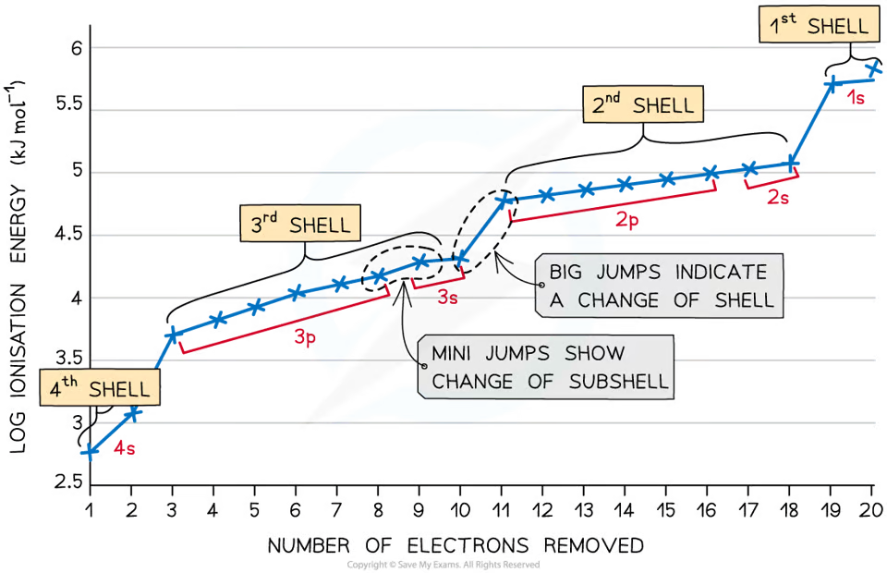
Why does First ionisation energy generally increase across periods | - Greater nuclear charge -> reduced atomic radius -> there is a greater attraction so more energy is required to remove an electron -> harder to remove outermost electron as more protons are added across the period  - During this, shielding stay the same
What is a metallic bond? | Strong electrostatic force of attraction between cations and delocalised electrons (2)
Why does the reactivity increase down group 2? | First ionisation energy decreases -> less energy required to remove the outermost electron
What is meant by the term charge density? (1) | The ratio of charge on ion to its volume (1)
What changes for group 2 carbonates down the group? | Solubility decreases and thermal stability increases and charge density decreases
How and why does Thermal stability/decomposition of Group 2 carbonates change as you go down the group? | - Thermal stability increases  - As the smaller metal ions at the top of the group distorts the carbonates more and has a larger charge density and so the ion would be more unstable compared to the larger ions at the bottom of the group  As the nucleus of the metal atom would attract electrons from the oxygen atoms
How do you make testing which group 2 carbonates are more thermally stable a more valid test? (e.g BaCO3 and CaCO3) | - Use the same amount/moles of carbonate (1)  - Use the idea of same heating intensity (1)  Apparatus could be heating carbonate in a test tube and passing gas using a delivery tube through into limewater or using a gas syringe or using a upside down measuring cylinder in water
Why is boron (1s² 2s² 2p¹)’s first ionisation energy less than beryllium (1s² 2s²)’s | P-orbital e- has a higher energy than the s-orbital e- -> it is easier to remove  It’s all about a new factor now having an effect relative to the previous element
Why is oxygen's (1s² 2s² 2p⁴)’s first ionisation energy less than nitrogen's (1s² 2s² 2p³)’s? | Electrons now pair in the same orbital therefore repel one another and is easier to remove
What changes for group 2 hydroxides down the group and why? | Solubility increases and alkalinity increases therefore more OH⁻ ions are released therefore higher pH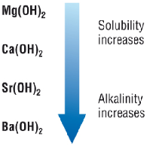
What is the flame colour for Li⁺ | Crimson red
What is the flame colour for Na⁺ | Yellow
What is the flame colour for K⁺ | Lilac
What is the flame colour for Ca⁺ | Brick red
What is the flame colour for Ba²⁺ | Apple green
What is the flame colour for Cu²⁺ | Blue green
What is the test for carbonates? | - Add HCl if you see effervescence it could contain a carbonate therefore a gas is produced  - Bubble this gas through limewater if it turns cloudy then the gas is CO₂ and thus a carbonate is present
Give the test for sulfate ions? | - Add HCl to dissolve any carbonates (aka a false positive which can mask desired observations)  - Add barium chloride solution (or barium nitrate)  - If white ppt forms you have a sulfate present  This is because Ba²⁺_{(aq)} + SO₄²⁻_{(aq)} -> BaSO₄ _{(s)}
In what order should you carry out anion tests? | Carbonate - Sulfate - Halide (CaSH)  - Adding Ba²⁺ to CO₃²⁻ produces a white ppt of BaCO₃  - Adding Ag⁺ to CO₃²⁻ produces a yellow-grey ppt of Ag₂CO₃  - Adding Ag⁺ to SO₄²⁻ produces a white ppt of Ag₂SO₄
Precipitate colour of Silver and Sodium hydroxide and compound is produced? | Brown and Silver oxide
Precipitate colour of Copper (II) and Sodium hydroxide? | Blue
Precipitate colour of Iron (II) and Sodium hydroxide? | Green
Precipitate colour of Iron (III) and Sodium hydroxide? | Orange brown
Which ions react with sodium hydroxide and produces a white ppt and dissolves in excess | Aluminium, Zinc
Which ions react with sodium hydroxide and produce a white ppt and does not dissolve in excess? | Lead (II), Calcium
What is the equation for the reaction of a Group 2 oxide (Calcium) and acid? | CaO + 2HCl = CaCl₂ + H₂O
What is the equation for a group 2 (calcium) reacting with water? | Ca + 2H₂O = Ca(OH)₂ + H₂
What is the equation for the reaction of a group 2 oxide (calcium) and water? | CaO + H₂O = Ca(OH)₂
What is the equation for the first and second ionisation energy of group 2 (Calcium) with state symbols? | Ca_{(g)} = Ca⁺_{(g)} + e⁻  Ca⁺(g) = Ca²⁺(g) + e⁻
What is the formula for the thermal decomposition of group 2 carbonates (calcium) with state symbols ? | CaCO_{3(s)} = CaO_{(s)} + CO_{2(g)}
Which nitrates are soluble? | All nitrates
Which Halides are insoluble and precipitate colour? (remember SC3L halides) | Silver Halides  Copper iodide (white)  Lead Chloride (white)  Lead Bromide (white)  Lead iodide (bright yellow)
Which Halides are soluble? | Most Halides
Which hydroxides are soluble (remember BSCALPS hydroxides) | Barium hydroxide  Sodium  Calcium  Ammonium  Lithium  Potassium  Strontium
Which hydroxides are insoluble? | Most Hydroxides
Which sulfates are soluble? | Most sulfates
Which sulfates are insoluble (remember BCLS sulfates) | Barium  Calcium  Lead  Silver sulfates  All 4 are white ppt
Which carbonates are soluble (remember PALS carbonates) | Potassium  Ammonium  Lithium  Sodium Carbonates
Which carbonates are insoluble and precipitate in colour (remember CS&MC)? | Copper Carbonate (Blue/Green)  Silver Carbonate (Yellow)  Most Carbonates and most others are white
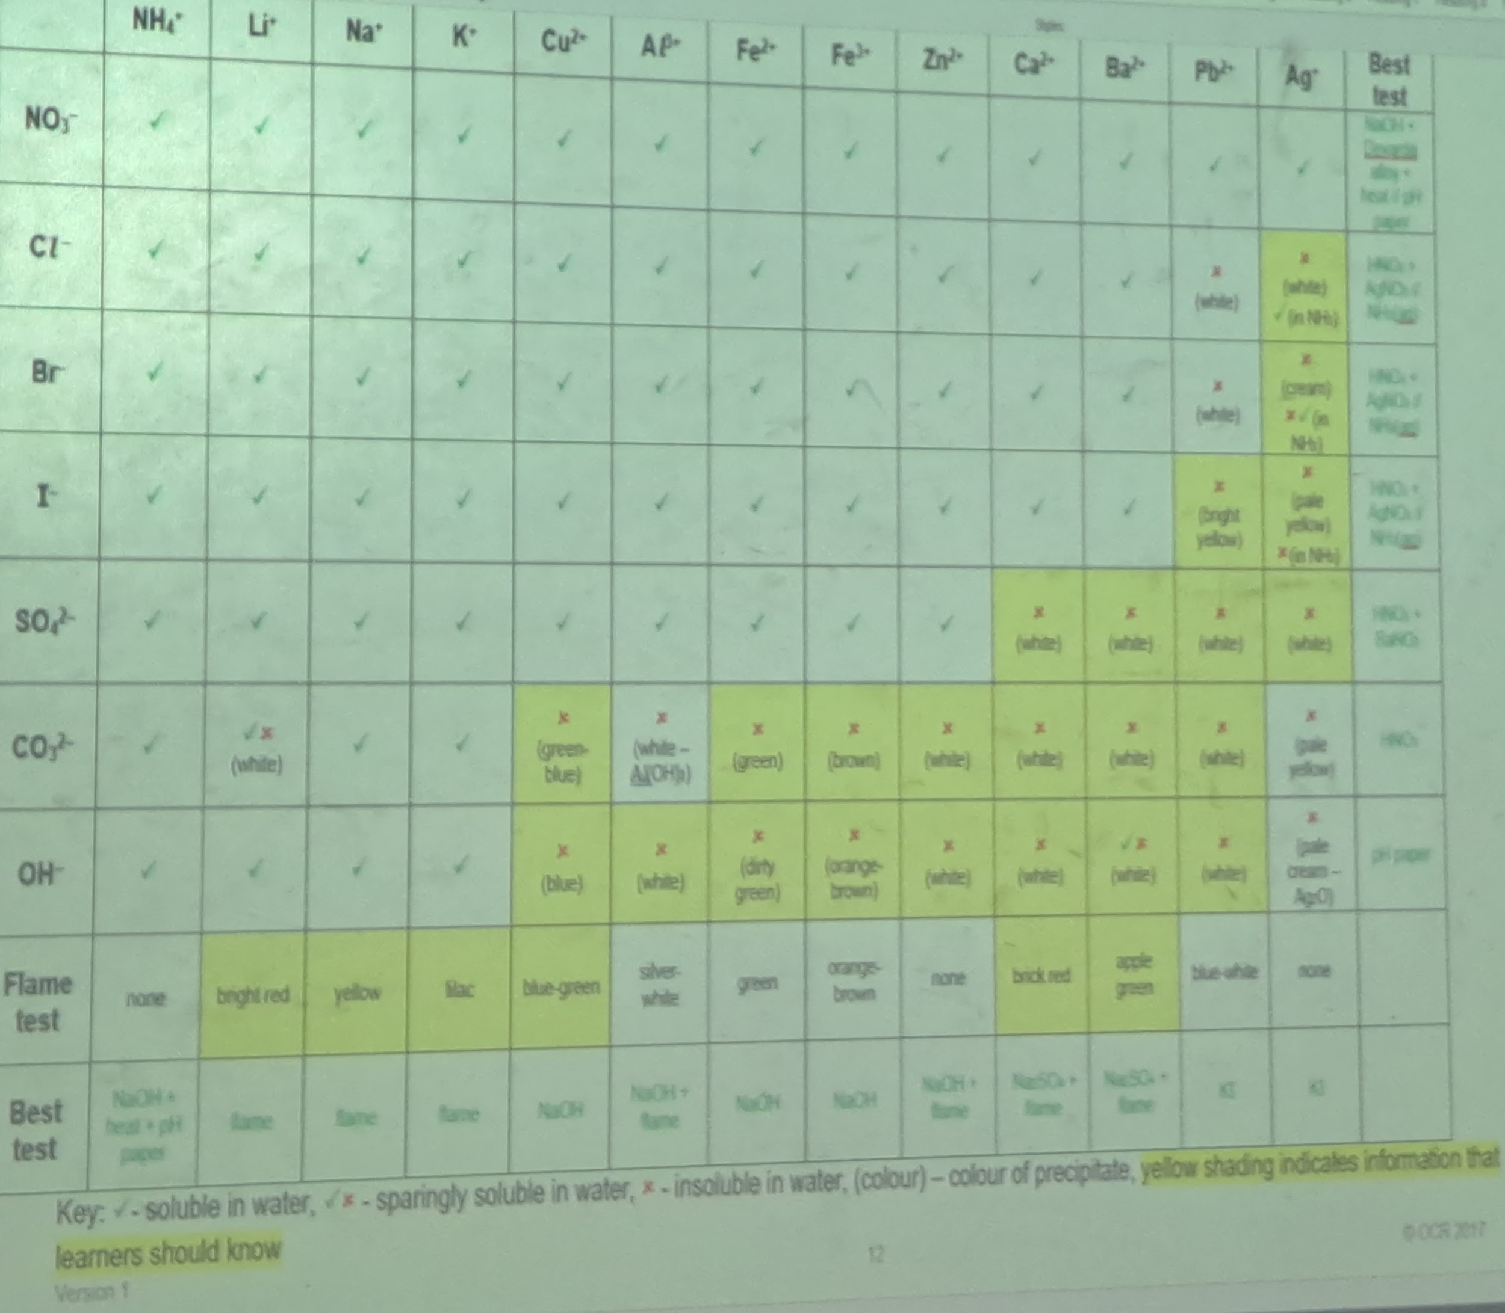
Why won’t all CO₂ be released from a reaction involving a solution? | As CO₂ is slightly soluble
Give 3 observations of a group 2 element in acid? | - More vigorous fizzing (down the group)  - Metal (ribbon) dissolving faster (down the group)  - Solution heating more (down the group)
What is the trend for solubility for the group 2 carbonates | Decreases as you go down the group  I.e. MgCO₃ is more soluble than BaCO₃ this is due to the cation forming weaker ion-dipoles with water molecules but this is in the topic 8 Oceans

EL.t-u - Equilibria (acid–base) | EL7 | EL8 | EL9 |

What is a salt? | The product of a neutralisation reaction where the H+ ions from the acid are replaced by metals or ammonium IONS
What is an acid? | A compound that dissociates in water to produce hydrogen ions
What is an acid regarded as? | A proton donor
What is a base? | A compound that reacts with an acid to produce water
What is a base regarded as? | A proton acceptor
What is an alkali? | A base that dissolves in water to produce hydroxide ions
What is neutralisation? | A type of reaction between an acid and an alkali
What is the equation for the reaction of an Acid + Base? | Acid + Base = Salt + Water
Reaction between an acid and metal (+ type of reaction) | Acid + metal = salt + hydrogen  Redox (not neutralisation as water isn’t formed)
Reaction between an acid and metal oxide | Acid + metal oxide = salt + water
Reaction between an acid and metal carbonate | Acid + metal carbonate = salt + water + CO₂
Reaction between an acid and metal hydroxide | Acid + metal hydroxide = salt + H₂
What is the method for preparing a soluble salt using an insoluble base/solid carbonate or , metal? | - Add excess solid base to acid (gently heat to speed up reaction)  - Filter off excess solid base  - Heat filtrate solution until volume reduced by half  - Cool solution and allow remaining water to evaporate slowly and crystals to form  - Filter or pick out crystals  - Leave crystals to dry
What is the method for preparing a soluble salt using an alkali? | 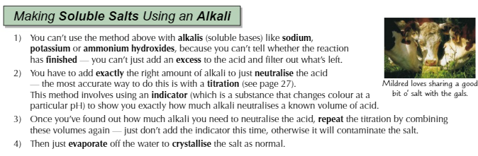
What would be in excess for preparing to make a soluble salt using an insoluble base + an acid? | The insoluble base
What is the method for a flame test? | - Use a nichrome wire  - Clean the wire by dipping it into concentrated HCl and then by heating it in a bunsen flame  - If the sample is not powered then grind it up  - Dip the wire in the solid and put it in the bunsen flame and observe the flame colour  If a question gives you the positive charged metal ion (cation) say the specific flame colour
What are the 2 concentration equations? | - Concentration = moles/volume  - Concentration = mass/volume  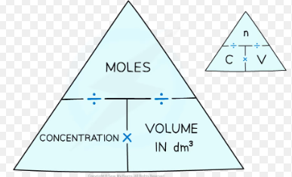
Explain the meaning of heating to a constant mass? (1) | Repeatedly heating and weighing the mass of a substance until there is no change in mass (1)

EL.v-w - Energy and matter | EL2 |

Explain why each element has a characteristic emission spectrum (4)? | As each element has electrons in discrete energy levels (1)) to which electrons drop levels (1) with different elements have different sized gaps (1) due to the energy released being proportional to frequency E=hv (1)
What is E=hv? | Energy = planck's constant x frequency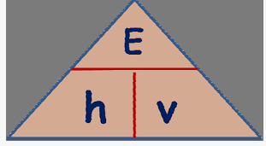
What is c = vλ? | Speed of light = frequency x wavelength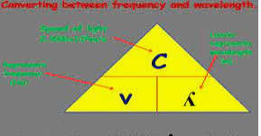
Explain how elements can give off coloured light when heated and how analysis of the light from strontium proved that it was a new element (6) | - Electrons when heated get excited and jump to a higher energy level by absorbing energy. (1)  - Energy levels for each element have a unique gap and a discrete amount of energy (2)  - When an electron falls down energy levels it emits radiation in the form of visible light in which its frequencies are related to colour via the equation E=hv and so each element emits a specific frequency of light when its electrons fall to a lower energy level. (3)  - Barium emits a frequency in the green part of the visible light spectrum but strontium emits a frequency from the red part (1)
What happens to the Energy, frequency and wavelength as you go from Infrared Radiation to Ultraviolet light in the EM spectrum left to right? | - Energy increases  - Frequency increases  - Wavelength decreases
What does an emission/line spectrum show? (3) | It shows the frequency of light given out when an electron moves down energy levels in the form of coloured bands on a black background with the lines getting closer together (converging) with increasing frequency
What does an absorption spectrum show? (3) | It shows the frequency of light absorbed by electrons in the form of black lines on a coloured background  with the lines getting closer together (converging) with increasing frequency
What is the equation for energy using wavelength? | Energy = planck’s constant x speed of light / wavelength (E = hc/λ)
What is the frequency/frequencies of light that the visible light spectrum is present in? | 10^14Hz

EL.x - Modern analytical techniques | EL1

What are the lines on a mass spectrum? | - If analysing elements they’re isotopes  - If analysing compounds they’re fragment ions
What does a mass spectrometer measure? | Mass to charge ratio (m/z)

